Transition from the Omiga Default Project lifecycle to one based on the Agile Unified Process (AUP)

A statement regarding the implementation approach to be adopted for the transition from the Omiga Default Project lifecycle to an Omiga Development Process based on the Agile Unified Process (AUP)

Alistair Webb
Mortgage Software Development
Version 0.1
6th November 2007

For Circulation to:

Martin Robson | Omiga Project Office Project Manager
Andy Green | Omiga Technology Refresh Project Manager

© Vertex Financial Services Ltd 2007

The contents of this report are the copyright of Vertex Financial Services Ltd and all rights reserved. No part of this document may be reproduced, stored in a retrieval system or transmitted, in any form or by any means electronic, mechanical, recording or otherwise, without the prior written consent of the copyright owner.
Document Control

Change Record

Date | Author | Version | Change Reference
06/11/2007 | Alistair Webb | 0.1 | Initial draft
12/11/2007 | Alistair Webb | 0.2 | Revised following review with:  Mark Gwilliam  Robin Clay  Russell Fairlie

Reviewers

Name | Position/Company

Contents
Introduction 4
Background & Purpose 4
Audience 4
The Process 5
Overview 5
High level plan and/or milestones 6
General 6
The transition plan: 6
Possible Quick-Wins 8
General 8
High level estimates for the change activity 10
Document Process & Procedures 10
Training 10
References 13
Useful web links 13
NOTES (to be removed from final version) 14

Figures
Figure 1 Process Overview 5

Introduction

Background & Purpose

The Mortgages Department uses a default development lifecycle that has a fairly traditional ‘waterfall’ style; The Project Office and the Technology Refresh Group are both interested promoting a move by the department to the use of a development lifecycle that is more aligned with industry trends. The solution being proposed is to adopt a streamlined version of IBM's Rational Unified Process ) called the Agile Unified Process (AUP). In practice a fully Agile process is unlikely to meet all our needs and a process that falls between RUP and AUP will be used.

This document describes the implementation approach that the Mortgages Department should adopt in order to move from the current process to the new AUP based process; in particular these points will be considered:

- High level plan and / or milestones
- Order in which we can start moving - identifying quick, high/low risk areas, artifacts with greatest benefit, issues etc
- A view on the level of change activity required at every milestone (listed above) i.e. new templates, training, new tools, and productivity reductions in early periods.
- Some high level estimates for the change activity

Audience
This document should be used as a reference for the following team roles:

- Project manager
- Analyst
- Architect
- Configuration manager
- Database developer
- Designer
- Developer
- Tester

The Process

Overview
The development process is broadly based on the Agile Unified Process. The process will emphasize the following key drivers:

- Iterative development
- Quality
- Team collaboration
- Agility

A graphical overview of the process:

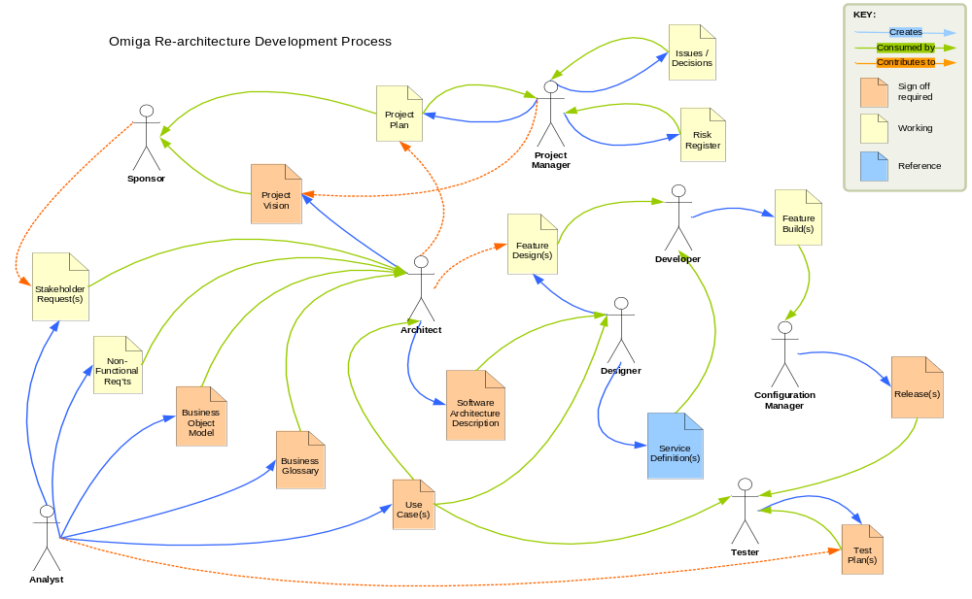
Figure 1 Process Overview

The diagram above shows the following key points:

- Team roles
- Artefacts
- Artefact owners
- Artefact consumers
- Artefact contributors

High level plan and/or milestones

General

The transition from a department wholly using the existing process to one wholly using the new process will necessarily be spread over some time. The transition will involve considerable culture change. To attempt such a transition in a ‘big bang’ approach would almost certainly fail.

We should adopt a strategy of gradual change that will reduce the risk to our projects that would arise from wholesale change. By making the transition project by project we will build up a pool of skilled individuals to seed subsequent projects and to mentor the team members new to the process and UML. By ensuring that the department’s key opinion forming individuals (project managers, analysts and developers) are trained and given experience early on in the transition then they will provide the department with a set of skilled resource able to tackle a significant project should the need arise before transition has completed. They will also be in a position to evangelise about the new process and techniques to gain broad acceptance from within the department.

The transition plan:

Milestone: Obtain agreement from project office

Present the new process to the Project Office team and obtain their feedback and agreement.

Activities:
- Create sufficient documentation to illustrate the new process to the project office team.
- Make the presentation
- Incorporate their feedback into the process
- Obtain their support to take the proposal to the management team

Milestone: Decision regarding choice of toolset.
The decision regarding choice of toolset may be made at any point prior to the pilot project starting but ideally the decision will be made prior to the presentation to the management team so that accurate costs can be included.

NB This is assumed to be Microsoft Team System

Activities:
- A policy decision on the use of open-source tools for example CruiseControl.Net should be obtained; if the department does not want to rely on unsupported software then these can be excluded from the appraisal.
- An appraisal of the available toolsets should be conducted. To include presentations from suppliers and use of evaluation versions if appropriate.

Milestone: Presentation to Management
Present the new process to the management team describing the merits of the new process and why this should be an improvement to our current process.

Activities:
- Create sufficient documentation including a visual presentation to illustrate the new process to the management team.

Milestone: Management Agreement Obtained
Obtain agreement from the management team to proceed with the next step of implementing the new process.

Activities:
- Obtain agreement from management team to proceed with the next step of implementing the new process.
- Authority to purchase necessary training and software licenses for the next step.

Milestone: Process Refined Following Peer Review
Refine proposal based on feedback from department.

Activities:

- Create sufficient documentation including a visual presentation to illustrate the new process to the department.
- Publish proposal and make presentations to the department describing the merits of the new process and why we need to change from our current process. Ask for feedback.
- Refine proposal based on feedback from department.

Milestone: Select a project to pilot the new process.
Select a project and team to pilot the new process. Select a ‘low risk’ small-scale project so that any reduction in productivity that results from the lack of experience within the team does not have an adverse impact on the department. Ideally ensure that at least one of the team has some experience in using a ‘Unified’ style development process so that he/she can act as mentor to the rest of the team. Try to use a number of key individuals (Project Manager, Analysts & Developers) from within the department so that they can take their experience and skills back to their regular projects.

NB This is assumed to be the first phase of the Omiga Re-Architecture Project.

Run the pilot project using the new process.

Activities:
- Identify the training needs for each of the team members and provide training as appropriate.
- Obtain licences for & install any new tools required to support the pilot project.
- Plan the project with some allowance for the inexperience of the team in the new process / UML.
- Create new templates for the significant new documents, for example a Use Case Template (example in Appendix A).
- Project Manage and run the pilot project using the new process, tools and artifacts.
- At the end of system test for each planned iterative release conduct a review and update the process as appropriate.

Milestone: Pilot project status a ‘Success’
Conduct a project review and if considered a ‘Success’ then refine the process as required. The definition of a ‘Success’ will include empirical and subjective tests, for example it could include:

- Project completed on time
- Project completed on budget
- The team members did not have to revert to the old process
- The team members believe that the new process is better / more effective than the existing process

The exact definition of success will be confirmed in the project documentation.
If not a success then reconsider if the process is the right one, do not continue with the roll out until a decision regarding the suitability of the process has been made.

Activities:
- Conduct a project review and obtain feedback from team.
- Refine the process as required.
- Demonstrate that the “Success” criteria have been met to management and obtain agreement to proceed with the phased rollout.
- Start to roll out training to department, implement the selected tools. This will allow analysts and developers to start using the new tools and techniques within the context of the current process to gain experience.

Milestone: Identify subsequent projects
Select the next project(s) to be run using the new process. Build teams around members of the original team so that the new teams have some experience to draw upon. Provide training as appropriate to the new team members.

Activities:
- Select the next project(s) to be run using the new process.
- Provide training as appropriate to the new team members.
- Implement the selected tools.
- Project manage and run the projects using the new process, tools and artefacts.
- Conduct project reviews and refine the process as appropriate.
- Continue the phased roll out in this manner until all project work is being undertaken using the new process.

Milestone: Transition complete.

All new project work being conducted using the new process.

Possible Quick-Wins

General

There may be elements of the new process that could be implemented immediately within the context of our current development process that will aid the longer-term aim of moving to the new process, a quick-win.

There are a number of difficulties or dangers associated with implementing these quick-wins including:

- If successful there may be a temptation to go no further with the transition.
- If unsuccessful there might be a tendency to write-off the transition program based on this limited experience.
- If the element of the new process to be applied to the old process is not selected carefully then it may not provide any productivity gain. For example should an enhancement to an existing Omiga project be documented with use cases there would almost certainly be a requirement to also keep the BFS and possibly the technical specifications up to date as well. There would have been more documentation created not less and it probably would have taken longer.

Any attempt to implement quick-wins should be undertaken with great care to ensure that there is a benefit to the selected project as well as the wider benefit of building up experience within the department.

Iterative & Collaborative Working:

The existing process includes an element of iteration in the way it describes the use of ‘work packages’. Typically these tend to be made up of groups of requirements that relate to a common functional area of the proposed system. Work packages tend to be quite large in scope and timescale. Several are usually worked on in parallel through Analysis, Design and Development and then released en-masse into System Test. The remaining packages are then worked on and released as a subsequent phase into system test.

These work packages could be constructed in such a way as to allow them to be treated more like the iterations in a ‘RUP’ or ‘AUP’ development lifecycle and released package by package into system test.

The work packages would have to be constructed in such a way as to allow the first and each subsequent package release (Iteration) to be tested as a whole without there being dependencies on later work packages. It would be important that the analyst and developer work together on the entire work package rather than say having an analyst do the UI design for multiple packages and another doing middle tier work for multiple packages and so on as this will inevitably lead to integration problems.

Test Driven Development (TDD):

There are likely to be gains in terms of productivity around the use of Test Driven Development (TDD) techniques.

Deploy Microsoft Team System early and use features that aid productivity, for example the integrated unit testing and unit test code coverage facilities. This will provide valuable experience in the use of the tool and in the TDD approach in advance of the full roll out of the new process.

The developer will need to identify appropriate opportunities to use TDD especially when working on a mature product like Omiga, as it would be easy to fall into the trap of spending a day writing the unit test code for a defect and then spending a half an hour making the fix. Developers should be encouraged to use TDD on new code.

Use of UML artifacts:

Those analysts that have had training in UML should be encouraged to start using UML artifacts to complement the normal analysis & design deliverables. This will have the effect of allowing the analysts and developers to gain experience in the use of these artifacts. Any of the UML artifacts could be used; I suspect some are more useful than others and will more readily fit into the existing process, for example sequence and collaboration diagrams. Again there is a danger of producing more not less documentation as the BFS and technical specs will still need to be maintained; analysts should use these diagrams to replace text that would have been created in the existing documents. Analysts should be encouraged to use UML when documenting new components.

High level estimates for the change activity

Document Process & Procedures

The Microsoft Team System comes with a pre-configured Agile style process template that can be used ‘out-of-the-box’. There may be advantages in adopting this proven process (Microsoft claim that they use it in-house) and then modifying it as required by experience. Some investigation is required.

The Project office will document the new process and procedures and create templates for new project artefacts where appropriate. The amount of work required will vary according to how much of the pre-configured process template and artefacts that are adopted or changed by experience as the rollout progresses.

Training

General

The table below shows the training requirements by role.

Training Requirements  Role | Project Office | Project Manager | Configuration Management | Architect / Technical Consultant | Analyst / Designer | Developer | DBA | Tester
New Process | X | X | X | X | X | X | X | X
Microsoft Team System | X | X | X | X | X | X | X | X
UML |  |  |  | X | X | X |  | X

All Roles will receive training appropriate to their role as follows:

- Internal training on the new process
- How to use Microsoft Team System – specific for the trainee’s role

Individuals whose role requires them to either create and understand UML documents or simply understand them will receive UML training.

There may be some ad-hoc training required, for example analysts may benefit from a session on Visio and Project Managers may need some guidance on how to plan for the new process (i.e. for a more iterative development life cycle).

Estimate for Training

In both the estimate of training costs for the pilot project team and for the department as a whole I have assumed that MS Team System and UML training will be provided by external suppliers at a cost of £400.00 per person per day. I have assumed that UML and MS Team System courses are each of 3 days duration.

Training Estimate – Pilot Project
The following table gives a high level estimate for the training requirements for the pilot project team. I have assumed that the team will be made up of a Project manager, two Analysts, two developers one of whom will be a Technical Consultant working in an Analyst/Developer role and one Tester.

Further investigation is required into the availability of suitable training courses. I have assumed that training in the new process will be provided internally.

Training
 | Est. | Internal Training |  | External Training |  |  |  |  | Training Course Cost
Role | Number | New Process | Total Days | Team System | UML |  | Total Days |  | Assume £400 per day
Developers | 2 | 1 | 2 | 3 | 3 |  | 12 |  | £4,800.00
DBAs | 0 | 1 | 0 | 3 | 1 |  | 0 |  | £0.00
Test Team | 1 | 1 | 1 | 3 | 2 |  | 5 |  | £2,000.00
Analyst Programmers / Technical Consultants | 1 | 1 | 1 | 3 | 3 |  | 6 |  | £2,400.00
Analysts | 1 | 1 | 1 | 1 | 3 |  | 4 |  | £1,600.00
Project Managers | 1 | 1 | 1 | 3 |  |  | 3 |  | £1,200.00
Total |  |  | 6 |  |  |  | 30 |  | £12,000.00

Training Estimate – Department

The following table gives a high level estimate for the training requirements for the department. I have assumed that UML and MS Team System courses are each of 3 days duration. Further investigation is required into the availability of suitable training courses. I have assumed that training in the new process will be provided internally. It is important to remember that this is not a single one off cost but is made up of many smaller ones incurred as each project team is trained in turn. This cost will be spread over the duration of the transition project that could be twelve to eighteen months.

Training
 | Est. | Internal Training |  | External Training |  |  |  |  | Training Course Cost
Role | Number | New Process | Total Days | Team System | UML |  | Total Days |  | Assume £400 per day
Developers | 20 | 1 | 20 | 3 | 3 |  | 120 |  | £48,000.00
DBAs | 2 | 1 | 2 | 3 | 1 |  | 8 |  | £3,200.00
Test Team | 8 | 1 | 8 | 3 | 2 |  | 40 |  | £16,000.00
Analyst Programmers / Technical Consultants / Some Senior Developers | 11 | 1 | 11 | 3 | 3 |  | 66 |  | £26,400.00
Analysts | 20 | 1 | 20 | 1 | 3 |  | 80 |  | £32,000.00
Project Managers | 8 | 1 | 8 | 3 |  |  | 24 |  | £9,600.00
Total |  |  | 69 |  |  |  | 338 |  | £135,200.00

Training – Some Other Options

Arranging for training to be provided on-site rather than off-site could reduce the overall cost significantly, especially if otherwise the course delegates would be claiming travel and accommodation in addition.

An alternative approach to training could be that a number of the individuals on the pilot project are given extensive training and they then run internal courses to train their colleagues on other teams. There are issues with in that not everybody is likely to take on the training role with relish and that these individuals are likely to be in high demand, so limiting their availability.

Tools

Please refer to the separate document being prepared by Mark Gwilliam.

This document is available at this location TODO Document Reference

References

The following documents have been used in the preparation of this document:

Document | Author
Omiga Development Process Statement.doc | Mark Gwilliam
E-Mail: Team System Costs | Adrian Stanley
Visual Studio and Team System Pricing as at 11-10-07.xls | Peter Evans

Useful web links
Product information:

http://msdn2.microsoft.com/en-gb/teamsystem

Tools:

http://www.nunit.org/
http://ncover.org/site/
http://sourceforge.net/projects/nant/
http://sourceforge.net/projects/ccnet/ (CruiseControl.NET)
http://www.testdriven.net/
http://www.gotdotnet.com/Team/FxCop/

Links to relevant background material for terms in this document:

http://en.wikipedia.org/wiki/Agile_Unified_Process
http://en.wikipedia.org/wiki/Unified_Process
http://en.wikipedia.org/wiki/Design_patterns
http://en.wikipedia.org/wiki/Test_driven_development
http://en.wikipedia.org/wiki/Refactoring
http://martinfowler.com/articles/continuousIntegration.html

NOTES (to be removed from final version)
Other documents / sections

- Defect process (will depend on toolset)
- Technical environment(s): all databases, servers, config settings etc.
- Build process

